AY2023-24 Seminar Handbook

General
Seminars are divided into two major groups Seminar Series and Special Lectures. The Seminar Series is further broken down into six classifications depending on their subject matter. Each classification has a faculty “Seminar Chairperson” for a designated period of time (usually one year), and the Seminar Chairperson’s Coordinator is responsible for all preparation involved in scheduling each seminar under that specific classification.

Seminars Series
 |  | Chairperson | Coordinator
BS | Biochemistry Seminar | Chong  Semlow | Rebecca Fox
CES | Chemical Engineering Seminar | Demirer | Aracely Sustaita
CPS | Chemical Physics Seminar | Chan  Cushing | Elisha Jung Okawa
IES | Inorganic-Electrochemical Seminar | See | Pat Anderson
IOS | Inorganic-Organometallic Seminar | Hadt | Pat Anderson
OCS | Organic Chemistry | Robb | Annette Luymes
CM2 | Center for Molecular and Cellular Medicine Seminar | Shapiro | Irina Meininger

Day of Week | Location | Seminar | Faculty Host | Coordinator | Phone
Monday | 147 Noyes | Inorganic-Electrochemistry (IES) | See | Pat Anderson | 6022
Tuesday | 147 Noyes | Chemical Physics (CPS) | Cushing, Chan | Elisha Jung Okawa | 3367
Wednesday | B122 Gates Annex | Organic Chemistry (OCS) | Robb | Annette Luymes | 6016
Thursday | B122 Gates Annex | Biochemistry | Chong, Semlow | Rebecca Fox | 6446
Thursday | 106 Spalding | Chemical Engineering | Demirer | Aracely Sustaita | 3654
Thursday | 151 Crellin | Molecular & Cellular Medicine (CM2) | Shapiro | Irina Meininger | 4637
Friday | 147 Noyes | Inorganic-Organometallic (IOS) | Hadt | Pat Anderson | 6022

Room Reservations – Anya Janowski (janowski@caltech.edu) or visit ccerooms.mhsoftware.com

Special Seminars and Lectures
BL | Beckman Lecture | Stoltz | Annette Luymes
BMSLOS | Bristol-Myers Squibb Lectures in Organic Synthesis | Robb | Annette Luymes
CCS | Chemistry Club Seminar | Hadt | Various
CGEL | Constantin G. Economou Memorial Lecture | Wang | Allison Kinard
DDS | Doctoral Dissertation Seminar | Graduate Student | Alison Ross  Allison Kinard  Rebecca Fox
DLOC | Dow Lecture in Organic Chemistry | Robb | Annette Luymes
DLOMC | Dow Lecture in Organometallic Chemistry | Agapie | Pat Anderson
HL | Ruth & Eddie Hughes Lecture | Rees | Rebecca Fox
HML | Harden McConnell Lecture | Weitekamp | Ann Mao
JDRL | John D. Roberts Lecture | Nelson | Annette Luymes
MAS | McCoy Award Seminar | Dougherty | Alison Ross
NDL | Norman Davidson Lecture | CCE/BBE  Campbell | BBE
PBDL | Peter B. Dervan Lecture | Barton | Sadie Rubalcava
PL | Pauling Lecture | Okumura | Elisha Jung-Okawa
RWVL | Robert W. Vaughan Lectureship in Chemical Engineering | Wang | Mi Kyung Kim
SL | Ernest H. Swift Lecture | Gray | Pat Anderson
WNLL | W. N. Lacey Lectureship in Chemical Engineering | Wang | Mi Kyung Kim

Duties of Seminar Coordinator

Scheduling
Date conflicts should be checked before booking a speaker. See the Institute Calendar first. If you want to schedule a talk that is not on your own seminar day of the week, please contact the administrative support person in charge of that day. If a schedule conflict cannot be resolved, the Division Operations Officer should be notified.

Confirmation
- Confirm time, place, and date
- Information required regarding the speaker
  - Name and title
  - Institute or company and department
  - Visa status, if not a United States citizen
  - Accommodation requirements
- Information required regarding the seminar
  - Host faculty member’s name
  - Title of seminar
  - Date, time, and place of seminar
  - Audio Visual needs
  - Projectionist
  - Refreshments
  - Honorarium amount/account(s) to be charged for special seminars (if not the seminar account number)

Refreshments
If refreshments are to be served, contact catering@caltech.edu or call ext. 4896.
Include what you would like, where and when it should be delivered, and provide them with an account number.

Reimbursements
After the visitor has left, it is the responsibility of the Seminar Coordinator to take care of any reimbursements.

Checklist
Fill in a Seminar Checklist for each Seminar Speaker. As various items are completed by the Seminar Coordinator, they should fill in and/or date each item on the Checklist (this is an easy way to keep track of all areas of responsibility, including seminar costs).
Sample checklists are included at the end of this section. They are easily adapted to suit the particular needs of each seminar.

Honoraria and Reimbursement of Expenses
The Seminar Coordinator is responsible for scheduling the seminar aspect of the guest speaker’s day in most instances.

Honoraria
A PTA Payment Request Form needs to be submitted via TechMart. If the guest speaker is not in the system, tax forms must be collected and verified before their profile can be added to the Oracle Supplier database. Please allow 10-15 business days for Supplier Management to send/receive tax documents, review for accuracy, and analyze payee’s tax status to determine applicable income tax withholding and reporting. Foreign individuals are required to submit additional forms (i.e. visa, passport, etc.). Payment Services cannot issue the honoraria until tax forms are received and tax verification is completed.

Reimbursement of Travel Expenses
All travel reports must be submitted via CardQuest.

Room Reservation Information
Room | Capacity | Link
Beckman Institute (all rooms) | Various | Submit all requests to biroomres@caltech.edu
Broad Center 100 | 90 | Submit all requests to bberooms@caltech.edu.
Crellin 151 | 48 | http://ccerooms.mhsoftware.com/
Noyes 147 | 85 | http://ccerooms.mhsoftware.com/
Noyes 153 | 134 | http://ccerooms.mhsoftware.com/
Schlinger 101 | 14 people around the table; 35 chairs; 60 standing | http://ccerooms.mhsoftware.com/
Schlinger 118 | 22 | Contact Irina Meininger (irina@cheme.caltech.edu; ext 4637)
Gates Annex B122 | 200 | http://ccerooms.mhsoftware.com/
Gates Annex B127 | 30 | http://ccerooms.mhsoftware.com/
Spalding 102 | 25 | http://ccerooms.mhsoftware.com/
Spalding 106 | 100 | http://ccerooms.mhsoftware.com/
Spalding 113 | 25 | Contact Irina Meininger (irina@cheme.caltech.edu; ext 4637)

Seminar Checklist

A. Seminar Chairperson
- Suggests possible speakers.
  - Sometime during Summer, the Seminar Chairperson sends a memo to the professors in the subgroup asking them to suggest Seminar Speakers they would like to have visit. After the list is compiled, the Seminar Chairperson and/or Seminar Coordinator will narrow down the list of Seminar Speakers to approximately twenty and send letters of invitation.
- At the beginning of September or October, send a memo Faculty with a list of Seminar Speakers.
  - We ask them to list which Seminar Speakers they will host as well as the name of the Student/Postdoc Host.
  - Projectionists should be identified at that time (if needed). They are paid hourly at the current minimum wage for a minimum of 2 hours.
- Signs travel expense reports. Payment requests --submitted through Techmart

B. Seminar Coordinator
The Seminar Coordinator functions as the contact person for the Seminar Speakers, and they provide administrative support to the Seminar Chairperson.
- Information to Obtain from the Speaker
  - Name and title
  - Institute or company and department
  - Copy of passport and visa if Speaker is not a United States citizen (necessary to process travel reimbursement). Most Speakers prefer wire transfer.
  - Accommodation requirements
  - Title of talk/abstract
  - Audio/visual requirements
- Scheduling
  - Confirm that seminar does not conflict with an already scheduled seminar or with a Division or Institute Faculty Meeting.
  - Enters each seminar into the Institute Calendar at https://www.caltech.edu/admin
  - Arranges LCD Projector with AV staff if necessary.
- Travel
  - Arranges accommodations, calendars, flyers, lunch reservations, transportation
  - Coordinates visits with other universities.
  - Make Athenaeum or hotel accommodations as soon as possible after being notified that a Seminar Speaker is coming. Even if the reservation must be canceled, it is better to have one well in advance. At certain times of the year the Athenaeum is booked because of special events or prospective graduate students visiting various departments (for example, from late February to early April). Make sure the Speaker is informed of the Athenaeum 96 hours (4 days) cancellation policy.
  - Provide Speaker with transportation options to Caltech (and other universities).
  - Coordinate the reimbursement of travel expenses with other universities (if your Speaker will be visiting other universities in the area).
- Administrative Support
  - Approximately one month before the seminar, send the Student/Postdoc Host the student information memo (see below).
  - Make a lunch reservation at the Athenaeum at least two days in advance.
  - Distribute the appointment schedule by email to everyone on the schedule (including the projectionist(s) and the administrative assistants of the professors meeting with the Speaker). Email the Appointment Memo/Schedule to the Faculty Host, Student/Postdoc Host, Speaker, and Faculty Host Administrative Assistant. The Appointment Memo includes: Athenaeum accommodations/policy, time place the Student/Postdoc Host will meet the Speaker and lunch/dinner information and Account No.
  - Prepare a Payment Request (Techmart) for dinner expenses reimbursement.
  - Keep a checklist with dates to make sure that everything has been completed.
- Information to Give to the Speaker
  - Initial letter of invitation (if invitation has not been made verbally or via email)
  - After the Seminar Speaker has decided on a date, the Seminar Coordinator will send an acknowledgment letter along with the following information packet:
  - Speaker Information Form (to be returned to Seminar Coordinator—see example)
  - Visitors to the Chemistry Department, Caltech information packet
  - Campus Map (Contact person name and phone number typed at the top of the page)
  - Map of Pasadena (showing Caltech, freeways, etc.)
  - PrimeTime/SuperShuttle/Uber/Lyft Information
  - Driving directions around L.A. and Pasadena if the Seminar Speaker is renting a car, as well as visitor parking form and instructions

C. Faculty Host
- Chooses Student/Postdoc Host.
- Usually accompanies the Seminar Speaker to dinner, although this is not required.

D. Student/Postdoc Host
At least one month before the seminar, the Seminar Coordinator will send a memo with some materials concerning the Seminar Speaker to the Student Host. The Student/Postdoc Host responsibilities are as follows:
- Coordinates appointment schedule.
  - The Student/Postdoc Host will consult with the Faculty Host before setting up the appointment schedule to determine who should be on the schedule.
  - The Student/Postdoc Host should make sure there are no large gaps in the appointment schedule. If a professor is unavailable to see the Seminar Speaker, the student host should ask if the research group could meet with the Speaker instead.
  - The Student/Postdoc Host should provide the name of the contact person for the research group.
- Arranges lunch/dinner.
  - The Student/Postdoc Host should ask the Seminar Speaker what type of restaurant he or she prefers before making the dinner reservation.
  - The Faculty Host will often handle the dinner reservation instead. The Student/Postdoc Host should include the Seminar Speaker’s spouse or partner in the lunch and dinner arrangements if that person is traveling with the Speaker.
- Accompanies Speaker to his or her appointments throughout the day.
  - The Student/Postdoc Host meets the Seminar Speaker at the Athenaeum, hotel, or other agreed-upon location and takes the Seminar Speaker to each of the scheduled appointments.
  - The Student/Postdoc Host needs to talk to the Speaker about the audio/visual requirements on the day of the seminar to make sure everything is ready for the presentation.
  - The Faculty or Student/Postdoc Host introduces the Seminar Speaker before the Speaker begins the presentation. The Student/Postdoc Host should check with the Faculty Host ahead of time to find out what they prefer. Information about the speaker is usually on their website (unless they are from Industry). The Student/Postdoc Host should prepare their introduction ahead of time so they can look professional without relying on their notes.
  - At the end of the lecture, the Student/Postdoc Host MUST stand up and act as master of ceremonies for the Q&A period. They should moderate the audience questions--NOT the Speaker.

Virtual Seminar Guide

General
While most seminars now have an in-person component or are in-person only, there may still be an occasion when you may have to conduct a seminar entirely virtually. More typically, a seminar will be held in a hybrid format. Please see “Hybrid Seminar Addendum” on Page 16 for additional information.

Scheduling the Seminar
Scheduling a Zoom meeting can be done through your access.caltech page. Select the “Zoom Video Conferencing” link in the Communications Services section to be taken to the Zoom login page. Once connected, navigate to the “Schedule a Meeting” link in the upper right-hand corner.
- Put your seminar’s title in the “Topic” box. No description is needed unless desired.
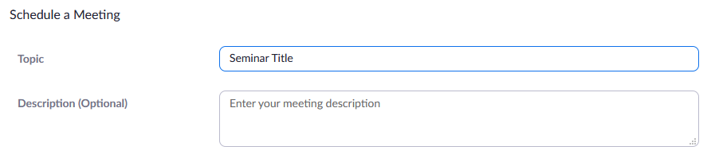
- Set the date, time, and duration of your seminar.
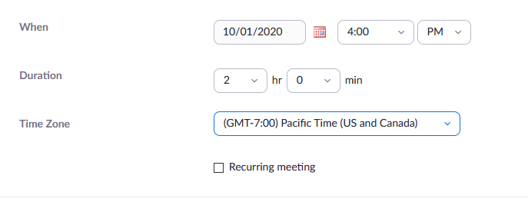

- You may choose to require attendees of your event to register by selecting the box next to “Required” as shown below. Alternately, you may choose instead to use a passcode in the Security section. Lastly, make sure you leave the setting for the meeting ID to generate automatically.
- You may create your own passcode as long as it has 6 characters. If you wish to require registration prior to the event rather than use a password, check that first “Required” box and leave the box next to “Passcode” unchecked.
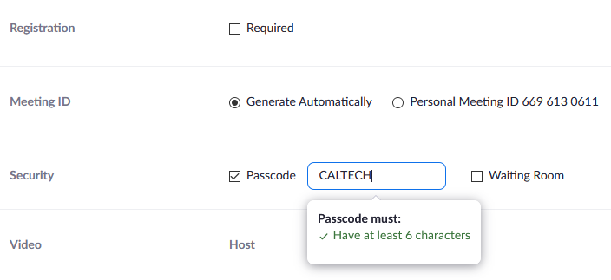
- In the Video section, it is not important whether you select that a Host or Participant’s video be “On” or “Off” as one can manually override this while in the seminar. As for the Audio, it may be best to select “Both” so users without an adequate speaker on their device may use their telephone to call in for their audio. You may also choose to limit audio for your seminar to “Computer Audio” to ensure security.
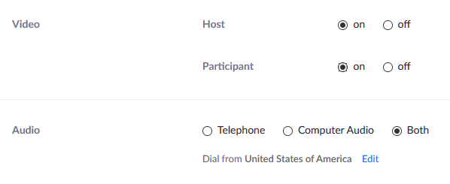

- It’s recommended to select “Mute participants upon entry,” as seen below. You can control mute options from within your seminar, as well.
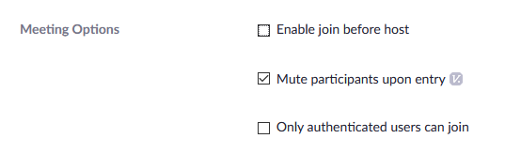
- This is also where you may limit your attendees to Caltech users, as shown below. It is not recommended at this time to limit your attendance to authenticated users as this will likely prevent your Speaker from accessing the meeting (unless they have a Caltech username). Should you wish to restrict your attendance, it is recommended you require registration instead.
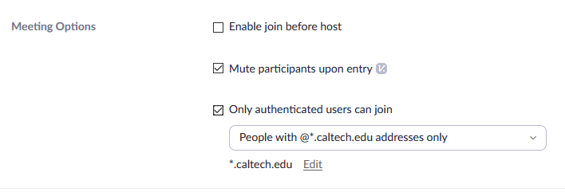
- Lastly, you may designate Alternate Hosts who may begin a meeting and hold similar managerial capabilities to the Host. Please note that you may only designate an Alternate Host who also has a Zoom Licensed account.

Zoom Settings
There are a number of meeting details you may select prior to scheduling your meeting. Please note: You must already have these options selected in your Settings before scheduling your seminar in order for them to be applicable.
- Waiting Rooms
One option that is very helpful for screening and security for your seminars is to enable the Waiting Room option. In addition to requiring all attendees register, this helps circumvent the issue of Speakers being unable to access the Zoom meeting because they do not have a Caltech email address. Within that “Edit Options” link, you’ll be able to select your preferred parameters for how to use the Waiting Room.
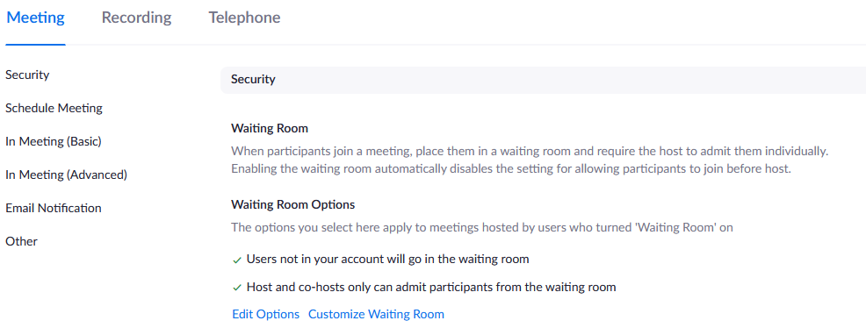
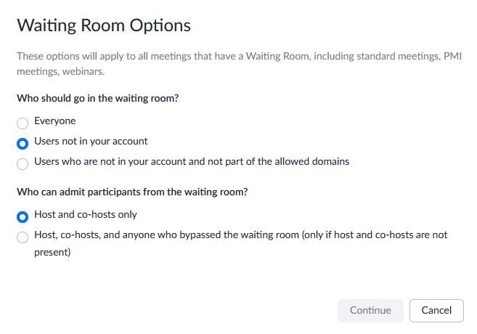

- Audio and Sound
Further down in the “In Meeting (Basic)” section of your settings, you’ll find the option to turn off the sound notification for when individuals join your seminar. In the image below, the sound notification option is turned off.
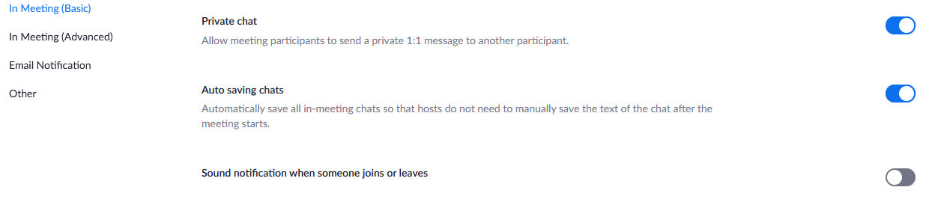
- Co-Host and Polling
Two other excellent options to consider can also be found in the “In Meeting (Basic)” section, the Co-Host and Polling options. Activating the co-host capability enables multiple people to hold administrative powers during a seminar, taking the pressure off of the main host or Speaker. Activating the Polling option will allow you to poll your attendees as a group through a pop-up.
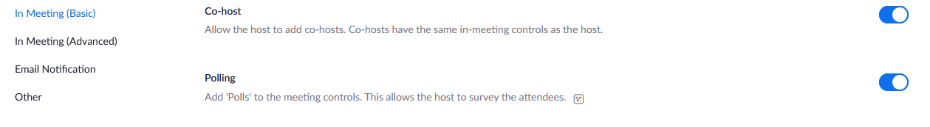
- Screen Sharing
Options for Screen Sharing are also within the “In Meeting (Basic)” section. In a seminar, you’d likely want to have the “Who can share?” option set to “Host Only.”
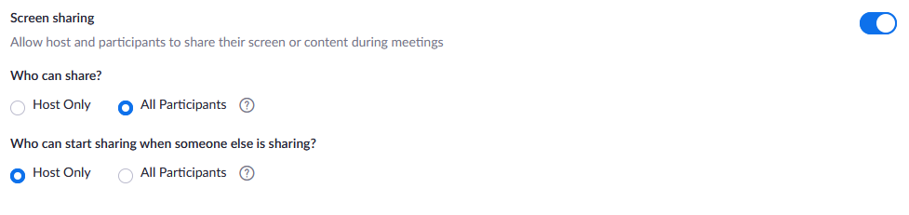
- Raising Hands
To allow your attendees to add reactions or raise their hand, you’ll need to adjust the following options. Having your attendees use the function to show a raised hand coupled with having them type their question in the Chat box can help to provide an orderly Question and Answer portion of your seminar.
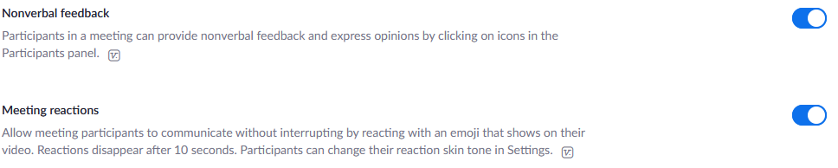
- Breakout Rooms
You may also wish to use breakout rooms to facilitate discussions in a smaller setting. You’ll need to be sure to have this option activated.
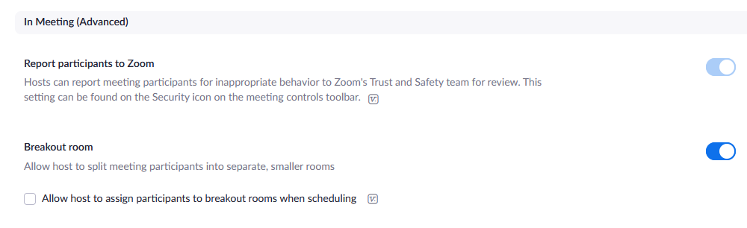
- Email Notifications
You can also adjust your email notification settings as you desire, for example making sure that all potential parties receive notification a recording is ready.
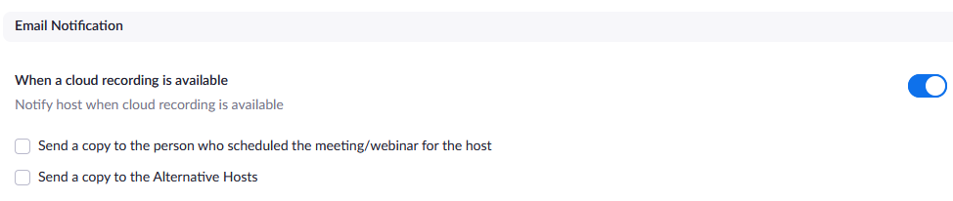
- Schedule Privileges
Lastly, this section is useful if your faculty member would like to grant you scheduling privileges on their behalf.
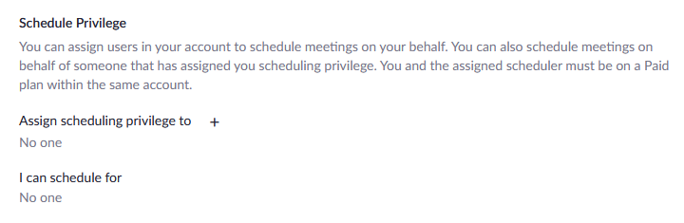
It is well worth it to closely examine all your potential options within your Settings. Again, be sure to activate or deactivate whatever features needed before you schedule your meeting in order for those changes to take effect.

- Taking Attendance in a Zoom Meeting
In the event you’d like to take attendance following a meeting, you may do so by exporting a Usage report through the “Reports” feature.
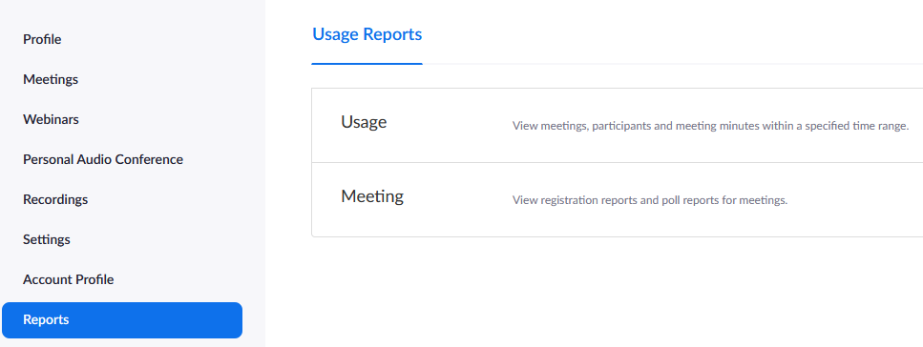
Once you’ve entered the Usage section, you’ll be able to locate by date the meeting for which you wish to access the user information. Click on the number in the Participants column to pull up the list of users present at the meeting.
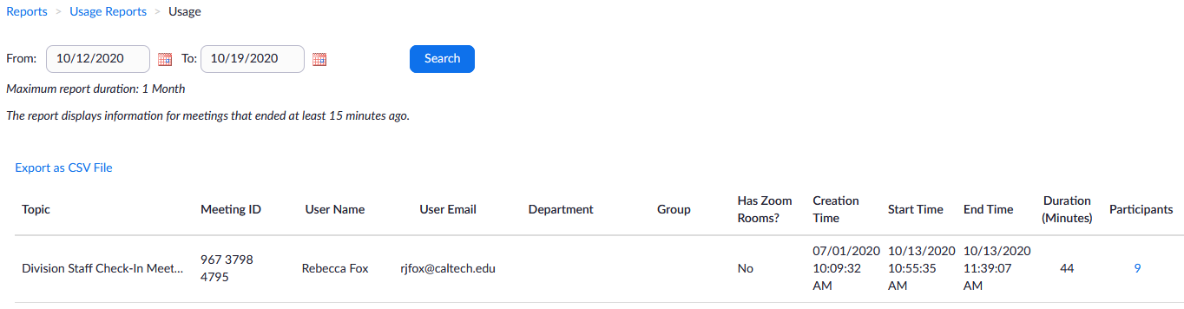
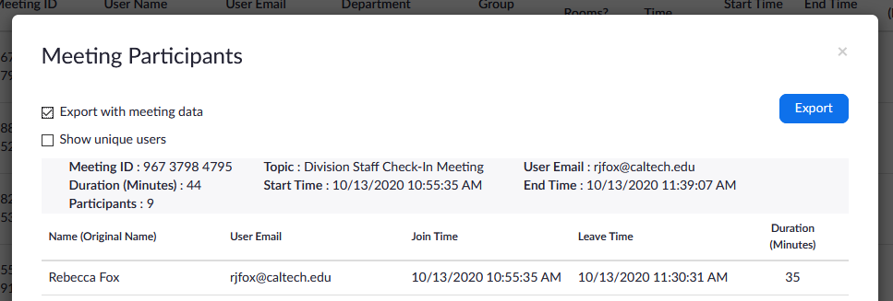
From there, an overlay will pop up that will prompt you to export that information as a .csv file which you may open with Excel. This will provide you with the list of users who joined the meeting and their entrance and exit times.

Hybrid Seminar Addendum

General
As COVID protocols have changed, there are no longer any requirements regarding social distancing or masks during our seminars. Zoom may still be utilized to allow attendees to join a seminar virtually, however whether a seminar will be in-person only or hybrid is the decision of the faculty host.
The Division has two Meeting Owl Pro cameras to assist with broadcasting the seminar speaker during their talk if the faculty would like to open the seminar up to those who are unable to attend in person. More information is provided below.

Using the Meeting Owl Pro
The Owl is a 360-degree camera that follows the speaker as they give their presentation. The Owl is also able to pick up and transmit audio.
Usage of one of the Owls is subject to availability. Please reserve in advance with Rebecca Fox. Reservations will be granted on a first-come, first-served basis.
The Owls are kept in the CCE Division Office (168 Crellin).
To operate the Owl:
- Plug in the Owl to a power source and use the USB cable to connect it to the computer. The Owl will connect automatically on its own.
- Open Zoom.
- Once you have started your meeting, go down to the bottom left-hand corner and click on the upward arrow to the right of the “Start Video” icon.
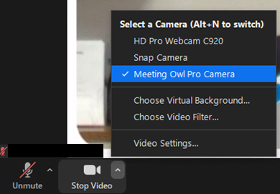
- Select “Meeting Owl Pro” to switch to the Owl’s camera. Upon doing so, you’ll see something that looks like the following:
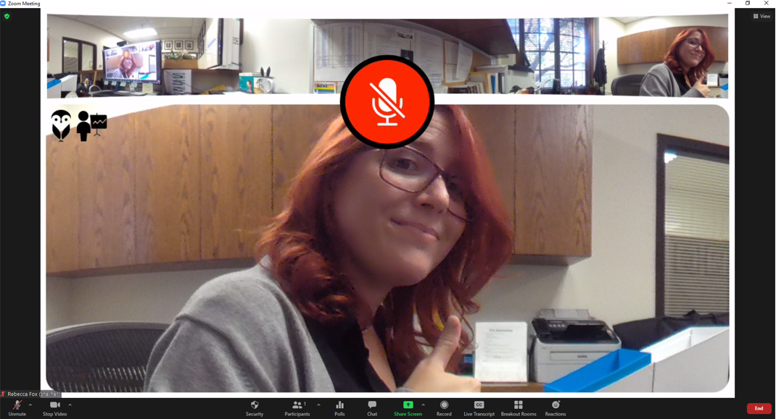
- The top of the window will show the full 360-degree view of the camera. The image below will show the person speaking at any given time near the Owl.
- Be sure to also select the Owl as the audio input in the same manner in which you chose it for the video.
The Owl will rotate its camera to follow the person speaking. No additional configuration is needed.
Once the seminar is done and you no longer need the Owl, simply unplug it from the computer and the power source. Return the Owl and its two cables to the box provided and then return everything to the CCE Division Office.

