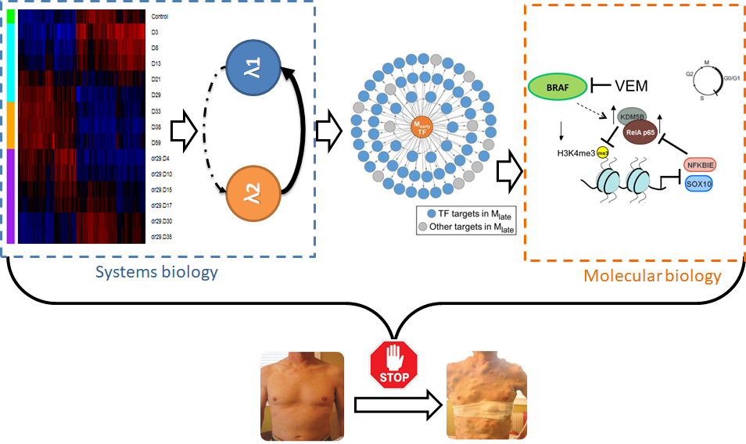

**Yapeng Su**

*(Heath, Davis and Baltimore groups)*

***“Resistance is Futile: systems biology and single-cell analysis to understanding drug resistance in cancer”***