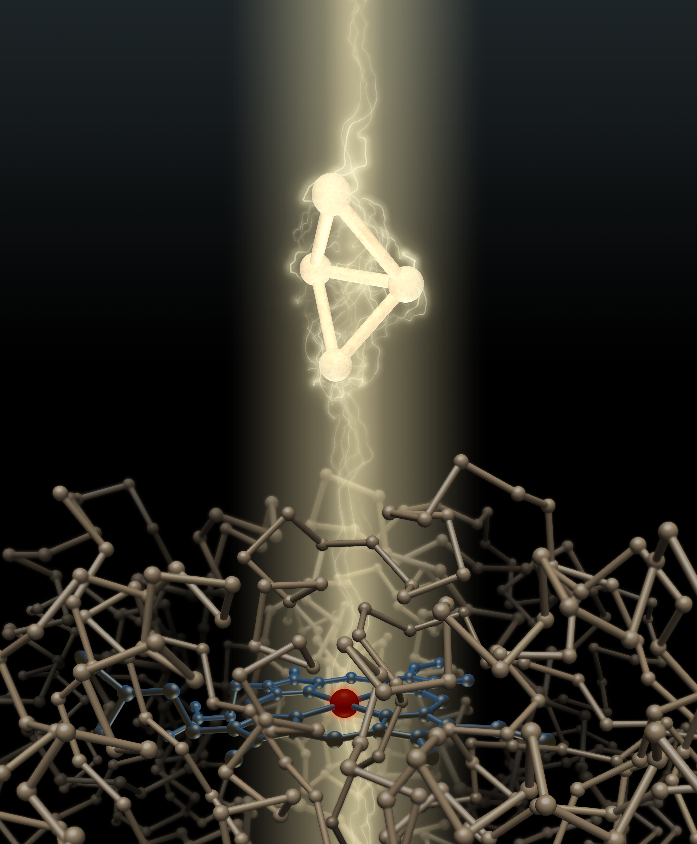

***“Expanding the Catalytic Repertoire of Hemeproteins as Carbene Transferases to Access Diverse Molecular Structures”***

**Kai Chen**

*(Arnold group)*